A Span Information Fusion-Based End-to-End Relation Extraction Model for Power Knowledge Graph
Qiong wang,Jing Wang,Yongbo Zhou
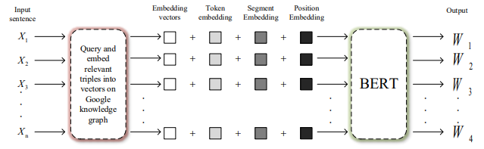
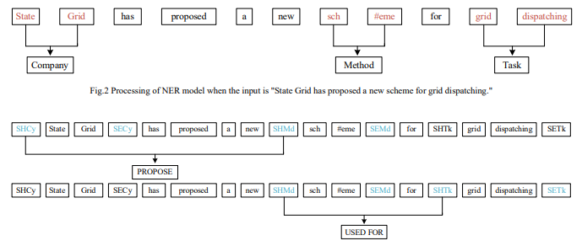

With the rapid development of the power industry, power companies have accumulated a large amount of data including industrial operations, system maintenance and project managements, etc. Especially for managers in power companies, how to efficiently reuse the massive amount of the business data for better decision making has become a challenging task. With the growth of project management data, how to handle these multi-source and possibly heterogeneous data has become a challenging problem.

- 1 We fuse external knowledge into the pre-trained model to achieve text augmentation.
2 We propose a span information fusion-based end-to-end entity relation extraction method.

Text Representation Augmented Pretrained Model
We embed the external knowledge into vectors and concatenate them to the input of BERT, so that the output of BERT contains the external knowledge. Its score function is:
$$f_{r}\left(h,t\right)={\left\|{\overline{h}}_{r,c}+{\overline{r}}_{c}-{\overline{t}}_{r,c}\right\|}_{2}^{2}+α{\left\|{\overline{r}}_{c}-\overline{r}\right\|}_{2}^{2}$$

Named Entity Recognition(NER) Model
This paper adopts the Span-level NER method to extract all possible fragment arrangements, and judges the entity type of each Span through SoftMax. Its loss function is:
$$L=-\sum_{s_{i}∈S}{{logP}_{e}\left(e_{i}^{*}|s_{i}\right)}$$

Relation Extraction(RE) Model
The goal of RE is to input a pair of spans to predict the relationship of the pair of spans. Its loss function is:
$$L_{r}=-\sum_{s_{i},s_{j}∈S_{G},s_{i}≠s_{j}}{{logP}_{r}\left(r_{i,j}^{*}|s_{i},s_{j}\right)}$$
The output of the final relation extraction model is:
$Y_{r}=\left\{\left(s_{i},s_{j},r\right),s_{i},s_{j}∈S,r∈R\right\}$
Background

Conclusion

Experiment

The datasets used in this paper are three datasets for project management in the power field: PPD03, PPD04, and PPD05.
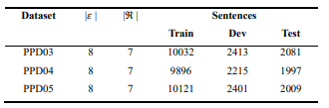
This paper uses the Adam optimizer and the warmup ratio is 0.1. This paper trains an entity model for 50 epochs ,the learning rate for pre-trained LMs is 1e-5, and others are 5e-4, the batch size is 16. On the RE model, this paper trains 10 epochs, the learning rate is 2e-5, and the batch size is 32. In this paper, the F1 value is used as the evaluation index of the model performance.
From the, it can be observed that the performance of SERE proposed is better than the joint extraction model in entity relation extraction, and SERE has the highest F1 score on the three power project management datasets of PPD03, PPD04, and PPD05.
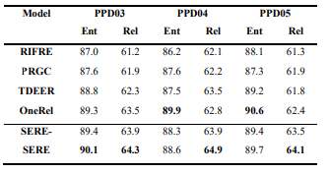

This paper proposes an end-to-end power project management relationship extraction method based on span enhancement. Experiments tell us that entity information can play a positive role in improving the performance of the RE model, and it also proves that the performance of the method we proposed is better than the joint extraction model.

Method

Overview

