Power Triplet Extraction Based on Knowledge Enhanced Representation

Hong Zhu,Wei Zhang,Xusheng Qian,Xinjie Sun,

Zhangliang Shen,Zijiang Hu,Zongze Jia

Methods

Thesis summary

Background

With the vigorous development of science and technology, the electric power industry is gradually informationized. The power system produces massive data every day, but how to mine these massive data for meaningful decision making. Knowledge graph can solve these problems well.

1 We propose an enhanced text representation method by combining domain and general knowledge.

2 Single-step triplet extraction is carried out through knowledge enhanced text representation.

3We experimented with the ELE dataset.



Conclusion

Experiment

We text-augment the output of BERT by fusing an external knowledge graph to make it contain more information, and the loss function is as follows:



We then use a new labeling method for entity relation extraction, and finally perform decoding. The loss function is:



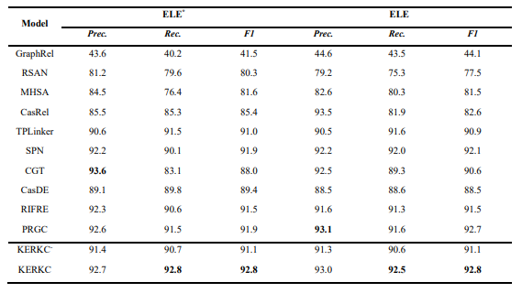

The table shows the partial matching and exact matching results of our model on ELE with 10 baselines. It can be clearly seen that KERKC is better than the other 10 baselines.

We provide a method for power triplet extraction with knowledge enhanced representation . For the words in the input sentence, firstly, the query was carried out on the large general knowledge graph, and embed the related triples into a vector that is connected to the output of the BERT, so that the concatenated vectors could have both domain and general knowledge. Based on this, triples are extracted to construct a knowledge graph. Experiments show that our method is feasible and has superior performance.